INDIA AIR POLLUTION DATA ANALYSIS

DATASET OVERVIEW:
The dataset contains historical air quality monitoring records collected from monitoring stations across multiple states and cities in India. It includes measurements of major air pollutants along with station information and sampling dates.

Dataset Information:
- Dataset Name: India Air Pollution Dataset
- Time Period: February 1990 – December 2015
- Total Records (Original): 436,074
- Records After Removing Duplicates: 435,400
- Number of Features: 13

Features Description
Column | Description
stn_code | Unique monitoring station identifier
sampling_date | Original sampling month and year
state | State where monitoring station is located
location | City/Location name
agency | Organization responsible for data collection
type | Type of monitoring area (Industrial, Residential, Rural, etc.)
so2 | Sulphur Dioxide concentration
no2 | Nitrogen Dioxide concentration
rspm | Respirable Suspended Particulate Matter
spm | Suspended Particulate Matter
location_monitoring_station | Monitoring station name
pm2_5 | PM2.5 concentration
date | Standardized sampling date

DATA QUALITY ISSUES IDENTIFIED:
The initial dataset contained several data quality issues that required pre-processing before analysis.
- 674 duplicate records.
- Missing values in multiple categorical columns.
- Missing values in pollutant concentration columns (SO₂, NO₂, RSPM, SPM, PM2.5).
- Missing monitoring station names.
- Missing sampling dates.
- Four records contained invalid dates (e.g., 31/06/2014, 31/09/2014).
- Date column stored as object type and required conversion to datetime format.

MISSING VALUES BEFORE CLEANING:
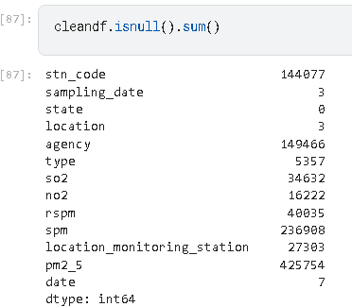

DATA CLEANING:
Removed Duplicates
Duplicate records were identified and removed to eliminate redundant observations and improve data quality.
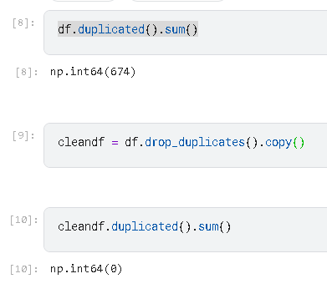
Handled Missing Values:
The missing values were handled using appropriate techniques based on the nature of each column.
- stn_code - Left as missing because it is a unique station identifier and cannot be reliably inferred.
- sampling_date - Negligible Missing Values
- location - Filled using the most frequent (mode) value within the corresponding state.

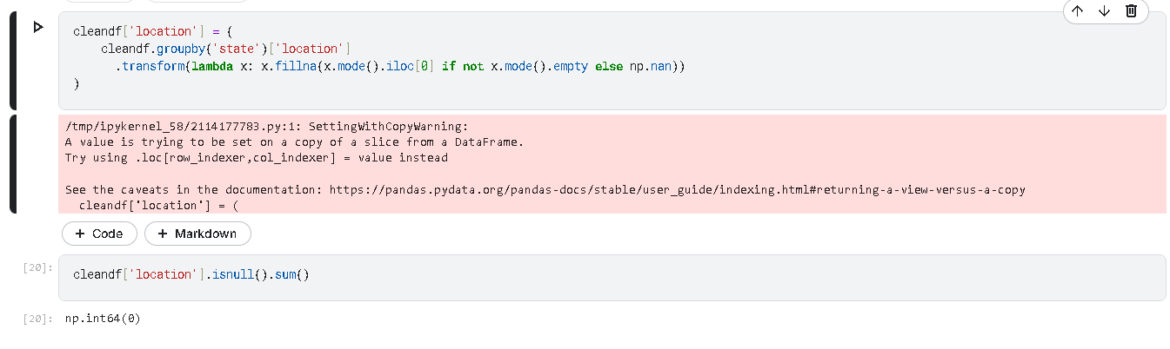

- agency - Replaced missing values with "Unknown" since the responsible agency could not be determined.

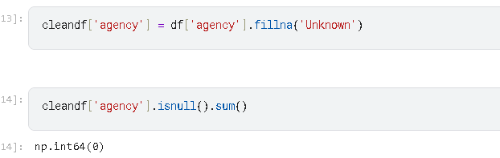

- type - Filled using the mode within the corresponding monitoring location.

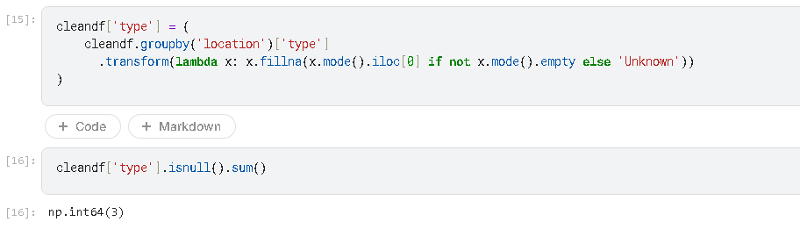

- location_monitoring_station - Filled using the mode within the corresponding location; if no information existed, replaced with "Unknown".

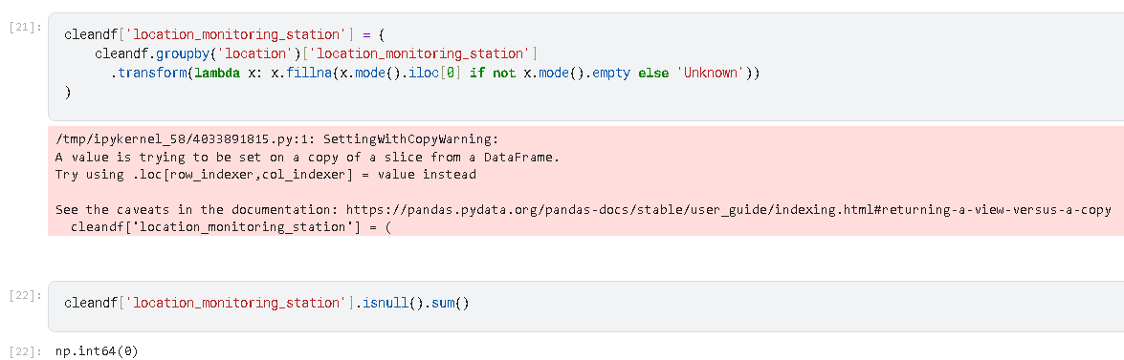

- SO₂ (so2) - Filled using the median concentration within each (state, location) group. Remaining values were left missing where no historical measurements existed.

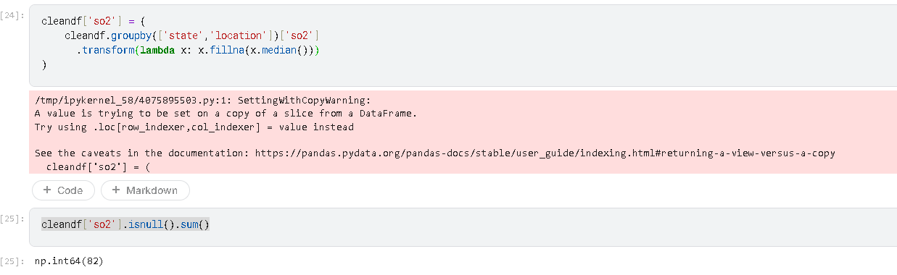

- NO₂ (no2) - Filled using the median concentration within each (state, location) group. Remaining values were retained as missing.

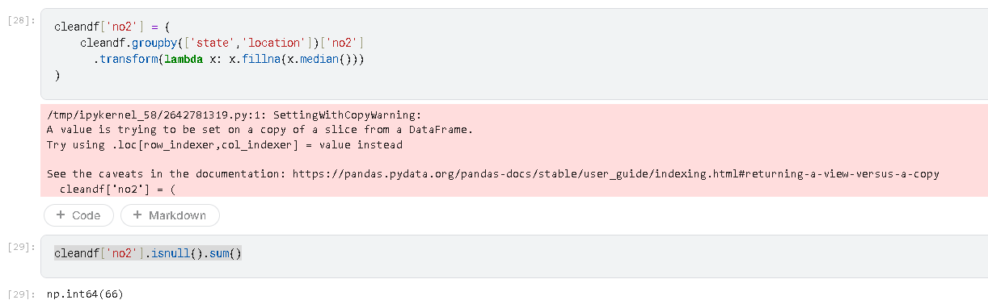

- RSPM (rspm) - Filled using the median concentration within each (state, location) group. Remaining missing values were preserved where measurements were unavailable.

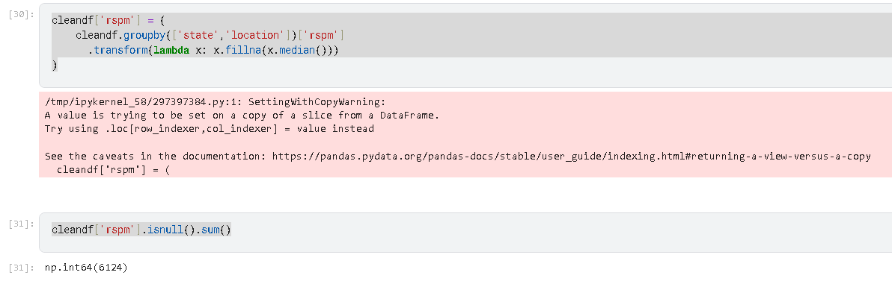

- SPM (spm) - Missing values retained because a significant portion of the dataset lacked SPM measurements, and imputation could introduce bias.

- PM2.5 (pm2_5) - Missing values retained since PM2.5 monitoring was unavailable for many historical records.

- date - Converted to datetime format. Missing dates were reconstructed from sampling_date where possible. Four records containing invalid dates (e.g., 31/06/2014) were removed.

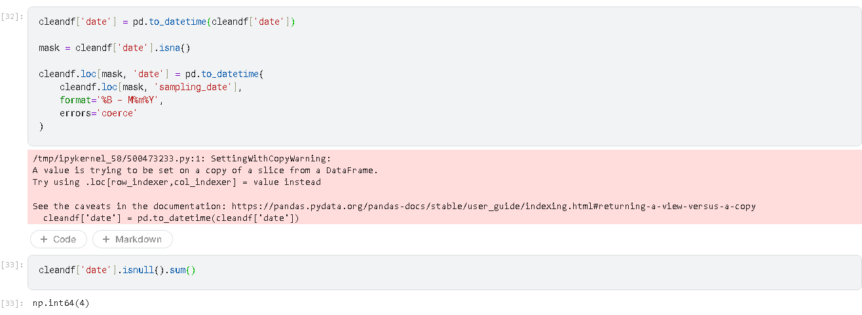

Final Missing Values After Cleaning

